Welcome to Wincanton Parish Church.

Christians have worshipped in Wincanton for over a thousand years and a church, dedicated to St Peter and St Paul, has stood on this site for many centuries.

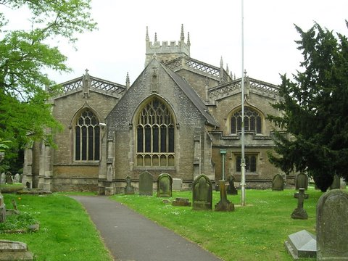

The Christian Church in Wincanton

There may have been a church building in Wincanton in Saxon times, though no trace remains and records for that time, as in the rest of Somerset, are scanty. Certainly the kings of Wessex were Christian from the time of king Ine (688 – 726) and our dedication to St Peter and St Paul is said to have been a favourite of his.

However, in the troubled times of the ninth century the mainly heathen Danes overran Wessex and ruled this area until they were finally defeated and expelled by Alfred in 878. Thereafter Somerset was part of a Christian kingdom. Its church was a part of the Church of Rome, looking to the Pope as its earthly head. Wincanton in those days was under the oversight of the Bishop of Sherborne, whose enormous diocese covered the whole of south-west England. In 909, Sherborne diocese was split up and Wincanton became, and remains to this day, a part of the diocese of Bath and Wells.

In 1534 Henry VIII broke with the Church of Rome and founded the Church of England with himself as “Supreme Head”. It was not at this time a Protestant Church but became so under Henry's successor Edward VI with the use of an English translation of the Bible and a Prayer Book in English. Church buildings underwent great changes at this time. Stone altars were replaced by wooden tables. Brightly painted statues and carvings of saints, the Blessed Virgin Mary and the Crucifixion were removed. Sculptures which could not be removed were often beheaded or defaced by extremists - there is an example in this church. Wall paintings were white-washed over and church interiors became much plainer.

There was a brief return to the Roman Church under Mary's short reign but Protestantism became largely accepted in England during the long reign of her sister Elizabeth I. Elizabeth ordered the keeping of registers of baptisms, marriages and funerals, but our earliest registers (now kept in the Somerset Heritage Centre in Taunton) only go back to 1636, in the reign of Charles I.

The Civil Wars of 1642 to 1648, followed by the Commonwealth under Oliver Cromwell were also times of religious turmoil. The Puritans objected to many church practices and preached a severe, sombre doctrine. Many parish clergy were replaced by Puritans, some of whom were themselves replaced following the Restoration of Charles II in 1660. The list of Wincanton vicars however, shows little turnover of clergy in the years between between 1635 and 1662, though our registers for this time are incomplete.

Under Charles II, whose Royal Arms hang, as he ordered, over the church door, a revised Prayer Book was prepared for the Church of England. It was hoped the revised book would unite most shades of Protestant opinion – but it did not do so and many broke away to become “Dissenters” or “Non-conformists”.
The revised 1662 version of the “Book of Common Prayer” is one of the defining documents of the Church of England. It is still in use here alongside the modern forms of worship.

Building and rebuilding

The church at Wincanton has been built and rebuilt many times.

There is no trace of Saxon or Norman masonry, at least above ground.

The oldest part now visible is the tower. The first three stages are medieval, possibly as early as the fourteenth century. The stonework of this part is different from the rest of the building. The stones are more irregular in size and include many grey-green blocks of “greensand” typical of the quarries around Penselwood.

The eighteenth century is often thought of as a very lethargic and inactive time for the Church of England but in Wincanton it was a time of great activity when the church building underwent major re-ordering and enlargement. Between 1735 and 1748 bells were re-cast, the south aisle was enlarged, clerestory windows were added and the other windows and the roof were rebuilt. The chancel was remodelled “in the Italian style” i.e. a semi-Classical style similar to the chancel of Bruton parish church. The architect at Bruton was Thomas Ireson of Ireson House in Wincanton and he was almost certainly in charge of the re-modelling here at Wincanton. The altar in the new chancel was given by Ireson at this time Finally, in 1793 the tower, then housing a clock and five bells, was raised by about 4m and a sixth bell added.

The church at this time was described as “...a pretty large edifice, plain without, but very handsome within...”

However, Ireson's church, his altar and a “fine toned” organ added in 1825, were not to survive.

By 1835 repair work was needed but efforts to raise the money by subscriptions failed and an attempt to levy a “church rate”in the town led to flat refusals, use of bailiffs to seize and sell goods in lieu and the resignation of churchwardens in protest. So the project lapsed until in 1885 a new Rector began again to raise subscriptions for renovation.

The Diocesan Architect, John Dando Sedding, was asked to report on the state of the building. He was a well-known and distinguished architect who had designed new churches and restored many others in London and in the West Country. He is described as a “passionate Gothicist” and was deeply involved in the Art and Craft movement.

Sedding's report was damning. The church, he wrote, was “one of the ugliest in the county”. He advised against repair and urged a complete rebuilding. Today one has to wonder whether the structural state of a basically hundred year old building really was that bad or whether the “Italian style” of Ireson was simply completely out of fashion at a time when enthusiasts for Gothic architecture saw it as the only “real” way to build a church.

Rebuilding was decided on and designs by Sedding himself and another architect C.E.Ponting were considered. Sedding's plans, based on fourteenth and fifteenth century Gothic styles, were chosen. The work was carried out between 1887 and 1889 and involved an almost total rebuilding, resulting in the church you see around you today.

Wincanton church today

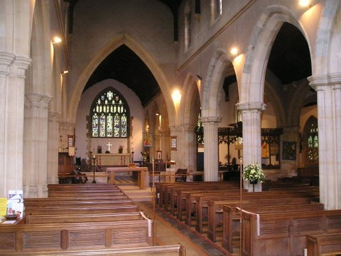

Look around you. The main structure is an elegant exercise in the fifteenth century Perpendicular style. The huge west window with its plain glass lights the nave brightly – indeed, the rays of the setting sun sometimes blind the lesson reader at evening service – and picks out the high altar at the eastern end.

Now look again. There is a second altar and a second nave to the south. It's a nave, not just an aisle because this was the centre of the old church, running from the tower to the old high altar. Walk to the glass doors at the foot of the tower. Inside, the brightly coloured bell ropes loop upwards in quiet repose. On Sundays and festivals they will be lowered and our eight bells will ring out. With your back to the bellropes, look up at the lines of arches running towards the brightly coloured east windows. To your right, the southern side, they are of uniform pale stone. To your left they are more varied, with grey-green “greensand” stones in the arches. These are old stones, re-used from the medieval church, though the arches must have been rebuilt at the 1887 reconstruction as the floor here is a metre higher than the old floor level. The old floor remains at the base of the tower and the bell-ringers stand on a suspended board floor which can flex - to the alarm of visiting ringers.

Look down at the aisle just beyond the edge of the carpet and you will see. the grey slate slabs of the Churchey family memorials, the earliest memorials in the church. The rebuilders moved them here from their original position in the chancel of the old church. Read, and puzzle out, their elegantly cut seventeenth century inscriptions.

Walk around the church. The font comes from the earlier building. The wall memorials from the eighteenth and early nineteenth century were also removed before the rebuilding and replaced near their original positions. Compare the names on these memorials with those in the “List of Incumbents” near the south door. See how the old Wincanton family names occur again and again.

There are a few late nineteenth century memorials in brass and stained glass, but, just 25 years after the rebuilt church was opened with rejoicing and hope, came 1914, the outbreak of the Great War and the end of the confident, ordered society of Edwardian Britain.

There are many sobering memorials to that dark time. In the south aisle is the War Memorial window, with the list of those killed in both world wars beneath. Take a few minutes to read the list and a few pages from “Not just names” (which records the stories of those killed in WW2) on the lectern alongside, and reflect. Look too at the carved wooden screen across the chancel step of the south nave. Admire the carving, then read the inscription on the left hand side. Look across to your left, to the “St George” window, also commemorating a Great War victim.
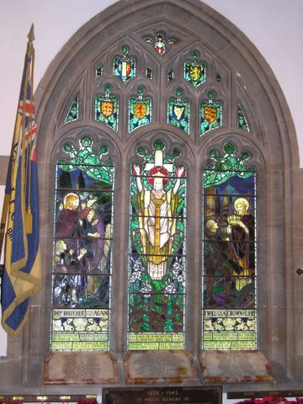

The ending of the Second World War is commemorated by the church bells. In 1946 the eighteenth century bells were recast and rehung on a new, steel frame and two new bells were added to make the present ring of eight.

The life of the church continues. Removing some of the Victorian pews from the back of the church has given space around the font, an area for serving refreshments and socialising after services, and a play area for young children.
For a last glance at the inside of the church, look at the embroidered banners hanging near the south door. The “Penselwood Wincanton” banner was worked by a children's group from both parishes and their leaders and the “Good Shepherd” banner by another group of children and Gill Weymont, our first woman curate, and one of the first group of women priests to be ordained in this diocese.

The outside of the church.

In the north porch, on your right hand side as you face the “Millers” inn, is the “St Eligius” stone. The carving is sharp and crisp but the figures have all had their heads crudely knocked off – almost certainly by Protestant extremists, “iconoclasts” or “idol-breakers,” at the time of the Reformation. So here is a tiny piece of the pre-Reformation decoration of the church.

It was found in a wall during the 1735 rebuilding.
The legend of St. Eligius
Eligius, or, as he is known in France, St Eloi, was born near Limoges about 588. He was a metal-worker, a goldsmith and banker, and became the Royal Treasurer. Under the next king, King Dagobert, he was made Bishop of Noyon, where he is buried. He is the patron saint of metal workers and farriers and , in the British Army, of REME, the Corps of Royal Electrical and Mechanical Engineers
French children sing an endless nursery rhyme about “Le bon roi Dagobert et le grand St Eloi.” and many legends are told of Eligius.
One of the best-known stories is illustrated here - the miracle of St Eloi and the horse.
“One day the good bishop was going about when he heard a great noise coming from a blacksmith's shop. There were crashes and cries and neighs. Eloi looked inside cautiously. “Whatever's the matter?” he asked. “Oh, my lord bishop”, said the smith, “it's this horse, I've been trying to shoe him but every time I go near him he goes mad!” “Oh,” said the bishop, “then give me the horseshoe.”
He turned to the horse, said “Peace be with you, brother” then stooped down and gently detached the horse's leg. He went to the anvil, picked up the hammer and nails and shod the hoof. Then he gently replaced the leg.”
Our carving shows Eloi, in his bishop's mitre, standing by the anvil with the detached leg in his hand. The hearth of the forge is behind him, with smith's tools hanging on the chimney hood. The horse stands quietly by, on three legs, while the smith has fallen to his knees in wonder. The horse's owner, on the other hand, stands stolidly by, holding the halter, blasé to the miracle.

Above the outside entrance of the porch is a magnificent carving showing our two patron saints, St Peter and St Paul. They hold their symbols, the keys of Heaven for Peter and a martyr's sword for Paul but a hundred years of smoky air have eroded the stonework, and only stumps of the sword now remain.

Leave the porch and walk round to the right, where you can see the side of the tower. There are no grave-stones on the grass beside the church wall. This is the site of the plague pit of 1552.

Look up at the tower. The gargoyles are in the wrong place! They project from the wall below the top windows and mark the height of the tower before the extra storey was added in 1793. Look hard at the top storey. How many sets of initials can you see? They MAY be those of the churchwardens of the time – or are they graffiti from daredevils who couldn't resist the opportunity to leave their mark on the new work while it was still surrounded by temptingly accessible scaffolding? There are more initials inside this part of the tower. The tower door shows the level of the old church floor. It is still used but there are several steps inside to reach the new floor level. There are still more initials on this side of the tower!

Continue walking round the church past the grating and steps down to the boiler room, until you reach the south door. Many Napoleonic prisoners of war were billeted in Wincanton and seventeen are buried in the churchyard. Only one of their gravestones remains today. It is a plain stone with a three-sided head near the churchyard wall opposite the south door of the church in the south-east corner of the churchyard. Its poignant epitaph is worth reading.
The south door was part of Ireson's Georgian church. It was moved a short distance and reassembled here at the rebuilding. Weathering has made the shield over the door unreadable.

Ireson himself is depicted behind you – the statue atop the tall plinth opposite the corner of the church. He designed, and may have made, the monument himself.

His right hand used to be the cleanest part of the statue because for many years, it was the custom of Saturday night passers-by to give him either a crisp-packet or beer-can to hold in this hand. Alas, one night someone swung too hard on the statue, it tilted, and Ireson's head fell off. The statue was righted and the head was replaced but later succumbed to another nocturnal admirer. The head has now been replaced a third time.

At the east end of the building admire Sedding's striking triple gables and the various tracery styles he employed for the parapets.

Tucked away at the foot of a buttress is the date-stone “1887” marking the start of the last rebuilding.

Until the early nineteenth century the churchyard was much smaller. The part between the east end of the church and the gates out to Church Street was added then and additional ground was also obtained by demolishing a cottage on the north side of the church. The handsome gates and gate pillars date from this time – though most of the accompanying wrought iron railings went for scrap metal salvage at the start of the Second World War.

After the provision of the present town cemetery the churchyard was closed for burials by an Order in Council of 1886. (There is a plan and key to the surviving memorial stones in the church, hanging up to the right of the main north door as you enter).
